Default State
- Device Off: The device remains off, waiting for the user to turn it on with a long press (4 seconds) on the tactile switch.

Active State
- Device On: When turned on, the device resumes the mode last selected before it was powered down.

Changing Modes
- Mode Selection: While in the active state, the user can toggle through the four modes by pressing the tactile switch. The modes are:
- Mode 1: Low power white
- Mode 2: Mid power white
- Mode 3: Full power white
- Mode 4: Full power red
- Mode Cycling: For example, if the device is in Mode 2 and the switch is pressed, it will change to Mode 3. Pressing the switch again will switch to Mode 4. Another press will return to Mode 1, and so on. The modes cycle consecutively based on the current mode.

Battery Indication
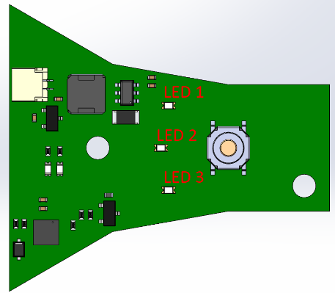
- Battery Level: In the active state during normal operation, the battery indicator LEDs should be off. When the button is held for 2 seconds, the device will check the battery level and indicate it using three battery indicator LEDs:
        - Below 20% charge: LED 1 will breathe in 3 second sequence (1 sec on, 1 sec off, 1 sec on)
        - 20% - 33% charge: LED 1 is on (3 seconds)
        - 34% - 66% charge: LED 1 & 2 are on (3 seconds)
        - 67% - 100% charge: LED 1, 2 & 3 are on (3 seconds)
NOTE: FW to be developed so timing for LED blinking/breathing can be adjusted before final release.

Charging Indication
- Charging Status: Battery level should be indicated during the charge cycle.
  - Charging at 0% - 33% charge: LED 1 will blink (1 sec on, 1 sec off?)
  - Charging at 34% - 66% charge: LED 1 is on, LED 2 will blink (1 sec on, 1 sec off?)
  - Charging at 67% - 99% charge: LED 1 & 2 are on, LED 3 will blink (1 sec on, 1 sec off?)
  - Fully charged: LED 1, 2 & 3 are on
- Charging Complete: All 3 LEDs will be on while plugged in. LEDs turn off when unplugged.

Turning Off the Device
- Power Off: In the active state, if the user presses and holds the switch for 4 seconds, the device will turn off.

